Procedure to install Matlab

Step-1:

* Open the below link <https://www.mathworks.com/products/matlab.html>

Step-2:



* Select the free trial and continue the below procedure.

Step-3:

* Get registered with mathworks with your contact details.

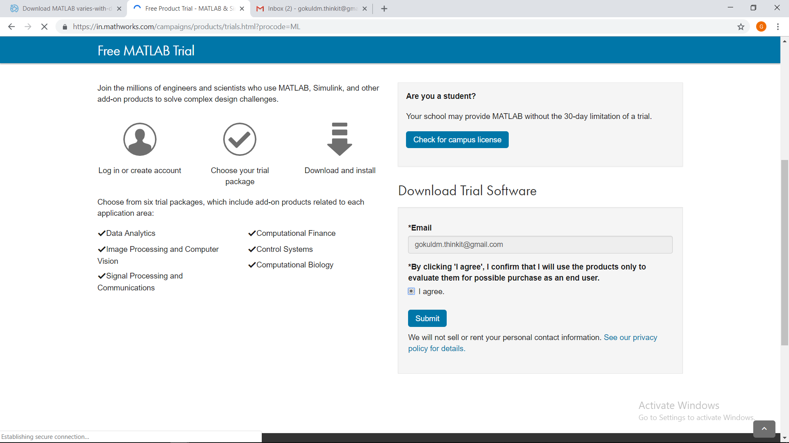

Step-4:

* Select the tool boxes needed (Recommended-Image processing and signal processing).

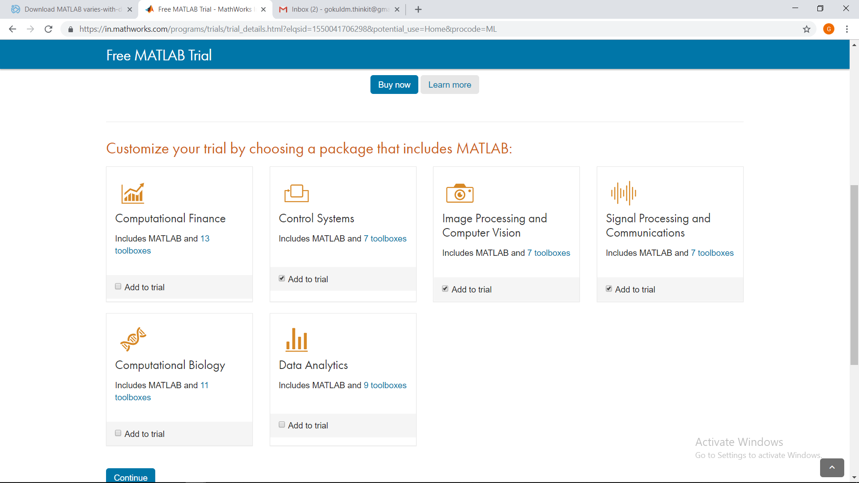

Step-5:

* Select the first option to download the free version of matlab

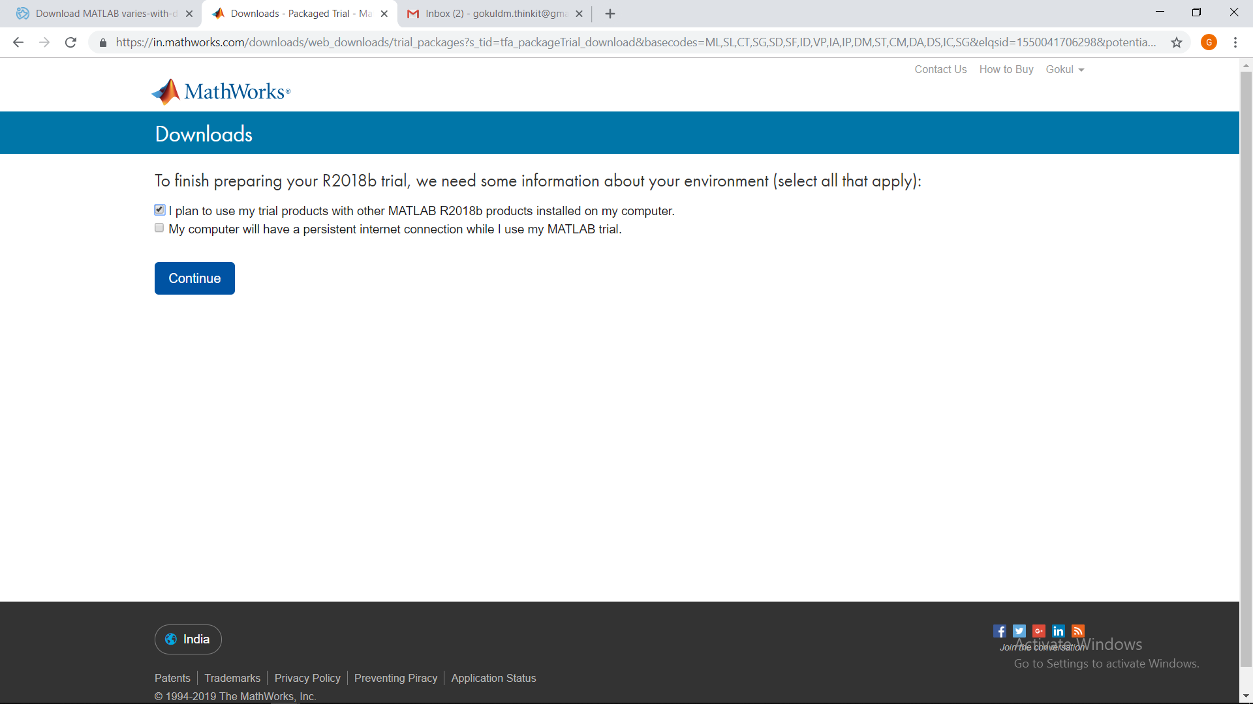

Step-6:

* Select the type of Windows, the software gets download.

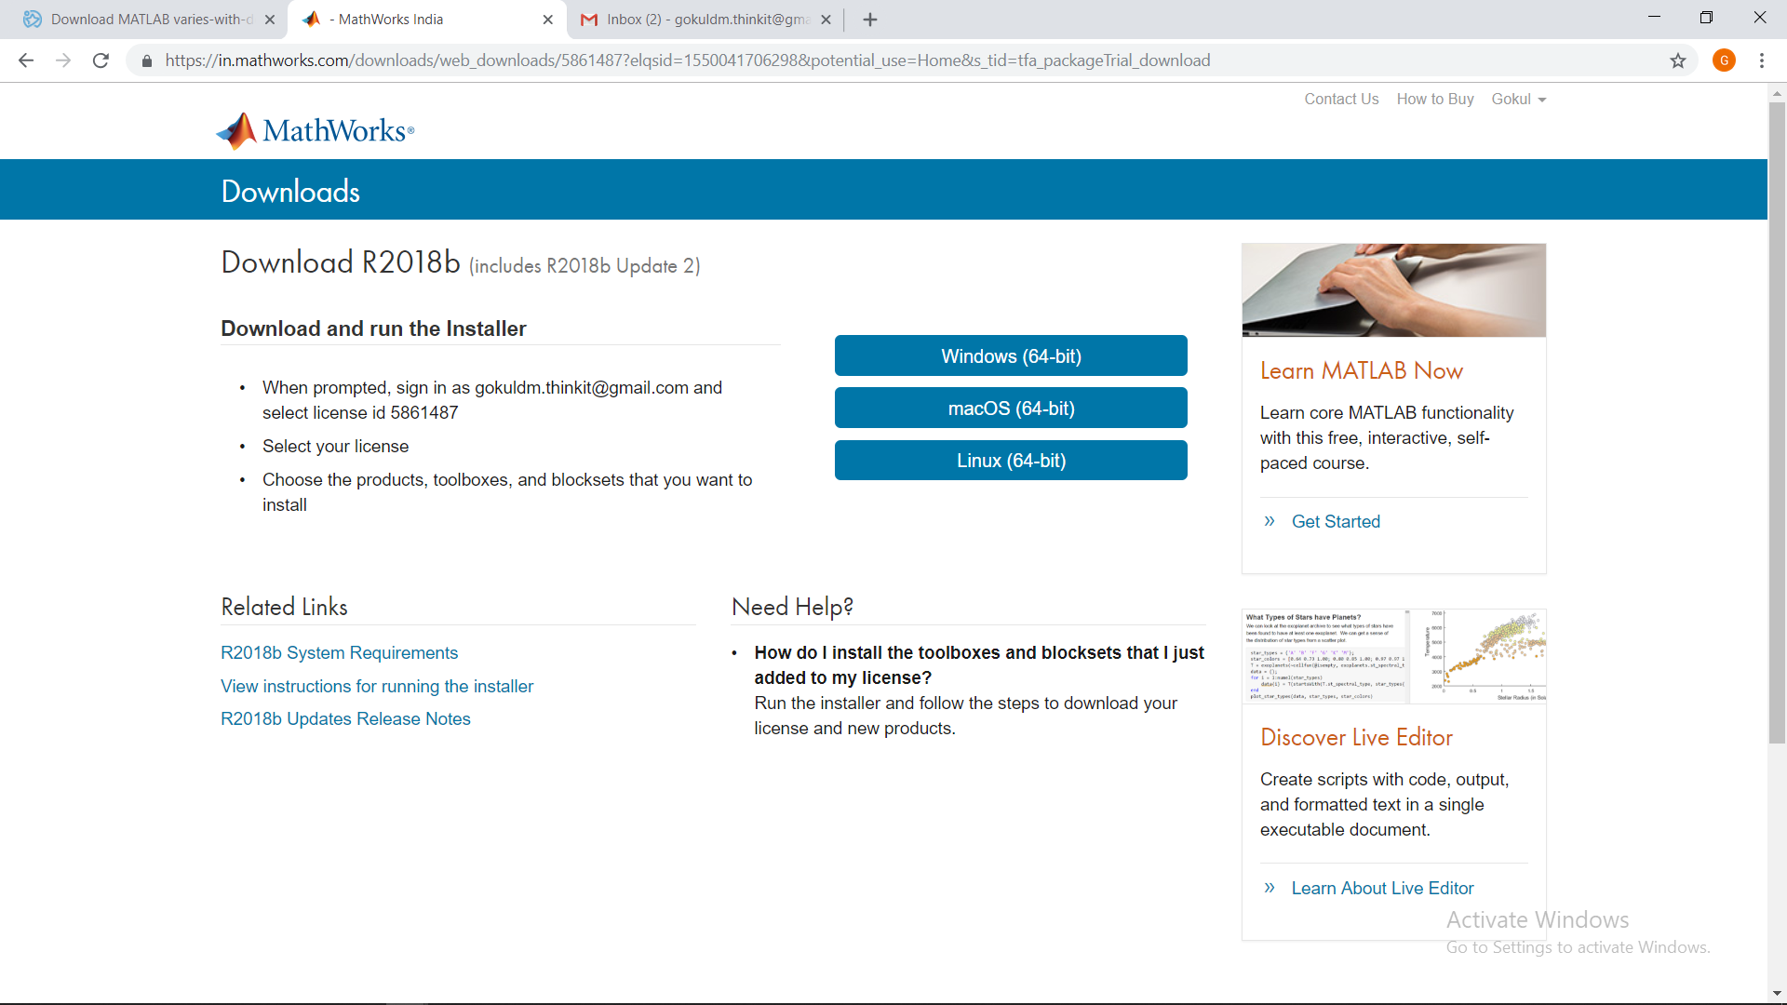

* Double click on the downloaded file, the software gets installed.